DEPARTMENT OF ENGLISH
S.NO | NAME WITH DESIGNATION | EMAIL.ID | PHOTO
1 | Mrs. A. Radhapriya  HOD and Assistant Professor  EXPERIENCE :  6 Years 3 Months | radhapriya.aasc@achariya.org | 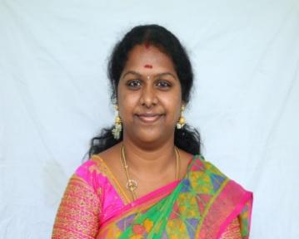
2 | Mrs. J. Umarani  Assistant Professor  EXPERIENCE :  7 Years 3 Months | umarani.aasc@achariya.org | 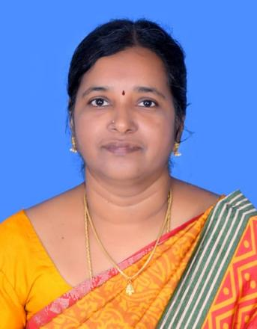
3 | Dr. V. Nithiya Parameswari  Assistant Professor  EXPERIENCE :  4 Years 11 Months | nithiyaparameswari.aasc@achariya.org | 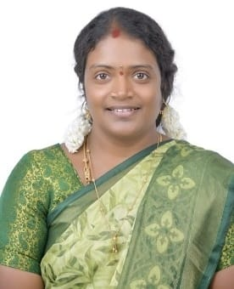
4 | Dr. V. Priyanga  Assistant Professor  EXPERIENCE :  8 Months | priyangav48@gmail.com | 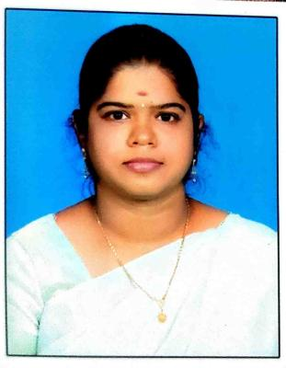
5 | Ms. N. Shalini  Assistant Professor  EXPERIENCE : 5 Months | shaliniabi4@gmail.com | 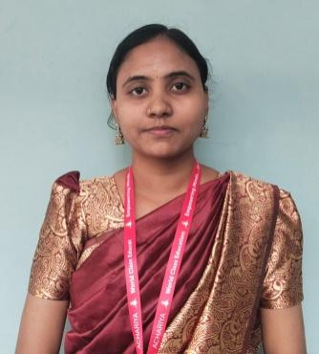
6 | Mrs. Kanimozhi  Assistant Professor  EXPERIENCE : 5 Months | kani.elit@gmail.com | 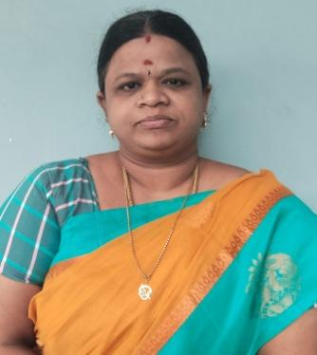

ABOUT THE DEPARTMENT :
The Department of English had its inception in the year 2009 and widened its horizon by having a huge strength of students and faculty members. It is led by a team of vibrant, aspirant, and experienced faculty members who always strive for the student’s community by grooming their thought -process and developing various skills.
The course with its title B.A. English is the culmination of both teaching language through literature and appreciating the aesthetics of literature through language. It serves with an aim of motivating the students to exhibit and to explore a wide range of new ideas in literature from the early, modern to the contemporary period.
The Department of English is instrumental in conducting various intra and intercollegiate competitions to continuously assess and evaluate the advancement of the students and to motivate them. The students put their heads and hearts together to participate actively in all the curricular, extra-curricular activities of the department in order to develop their self-confidence and leadership qualities which would transform them into responsible citizens.

The Department has its special feature of conducting Literary Meet competition every year to create an opportunity to accelerate the hidden talent of the young minds and also to train them to be morally and intellectually aspiring individuals. The Department also periodically organizes Guest Lectures, Literary forums, Seminars, Workshops, Industrial visits, and Library Visits which all form a part of the curriculum whereby students are exposed to inculcate and exhibit their creativity so as to increase the job opportunities to face the challenging world.

The Department has been credited with a considerable amount of prizes and recognition each year by conducting different innovative activities.

DEPARTMENTAL ACTIVITY REPORT
DEPARTMENT ACTIVITY 2021 - 2022
- The department inaugurated Literary Club in the year 2012. The department has its special feature of conducting Literary Meet every year to create an opportunity to accelerate the hidden talent of the young minds and to train them to be morally and intellectually aspiring individuals.
- The department inaugurated Literary Club in the year 2012. The department has its special feature of conducting Literary Meet every year to create an opportunity to accelerate the hidden talent of the young minds and to train them to be morally and intellectually aspiring individuals.
DEPARTMENT ACTIVITY 2022 - 2023
- The Department organized a programme titled “Navigating Indian English Vowels and Its Categories” on 14th October 2022.The session was handled by Mrs. D. Arpana, a Master in Linguistics.The programme focused on the features and classification of Indian English vowels.The session was informative and beneficial for students’ phonetic understanding.
- The Department organized a programme titled “Literary Criticism: A Demystified Approach.” The session was handled by Dr. M. Sivapriya, Assistant Professor, Bharathidasan Arts and Science College.The programme aimed to simplify major concepts in literary criticism for better understanding.The session was informative and academically enriching for the students.
- The Department conducted a programme titled “Sri Lankan Tamil Literature: An Overview” on 15th March 2024.The lecture was delivered by Dr. R. Indumathy, Assistant Professor of English.The session explored the origins, major themes, and cultural importance of Sri Lankan Tamil literature.The programme enhanced students’ understanding and appreciation of the literary tradition.
4. Readathon 24 The Department organized Readathon 24 on 24th March 2023.Engaging activities such as tongue twister, spell bee, and word race were conducted.The programme encouraged language skills and active student participation.
5. Higher Education in the UK and Employability Post Studies in a UK University.A session on Higher Education in the UK and Employability Post Studies in a UK University was held on 8th July 2022.The programme was led by Mr. M. Mohammed Hashique.The talk provided guidance on academic opportunities and career prospects abroad.
6. The Department hosted a programme titled “Understanding Postcoloniality: An Interpretation of Select Texts” on 13th March 2023.The session was delivered by Dr. N. Chandra, Assistant Professor, Bharathidasan Government College for Women.The lecture offered critical insights into postcolonial theory through literary texts.
7.The Department organized Literary Meet 2k23 on 26th April 2023 as a valedictory function with prize distribution.The event featured a musical feast and an engaging stage magic show.The performances were evaluated by Mr. M. Jaivno (Mayuri Chithira Natyalaya) and Ms. Vijayalakshmi (Director, Team Vishakdha).

8.A Book Release Ceremony was held on 24th April 2023.The books released were Shadow of Sweet Melodies, Stream of Rhythmical Thoughts, and Must Oh Heavenly Meadows.The event celebrated creative writing and encouraged literary expression among readers and writers.
- The Department conducted a programme on Career Readiness and Job Skills on 18th and 19th May 2023.The sessions were handled by Mr. R. Srinivasan.The programme focused on employability skills, career planning, and workplace preparedness.
- Jun-E-Verse 2k23, an intra-collegiate poetry competition, was held on 9th June 2023 with the theme “Summer Vibes”. The event provided a creative platform for students to showcase poetic expression and originality.
- The Literary Forum was inaugurated on 27th October 2022.The forum was initiated to encourage students to express their thoughts and ideas through language and literature.
DEPARTMENT ACTIVITY 2023 - 2024
1.The Department observed Constitution Day on 26th November 2024.An elocution competition on the topic “The Role of the Constitution in Shaping Modern India” was conducted.The programme created awareness about constitutional values and democratic principles among students.
2. A National Symposium titled “Life, Literature and Culture” was organized by the Department of English, Bharathidasan Government College for Women on 14th November 2024.
The symposium enabled students to gain academic insights and engage in meaningful interactions with teachers and scholars from various institutions
3.Freedom Fest 2k24 was conducted on 13th August 2024.Elocution and essay writing competitions were organized to commemorate the spirit of independence.The programme encouraged patriotic thinking and critical expression among students.
4. A one-day National Level Workshop on Content Writing was held on 21st November 2024.The session was led by Mr. N. Mohandas Ganthi, Project Manager, IGNITE Labs, Puducherry.Around 60 students from various colleges actively participated and enhanced their writing skills.
5. The Department organized Literary Film Week from 18th to 20th November 2024.The films screened were Troy, Pride and Prejudice, and I, Robot.The programme aimed to help students understand literature through cinematic interpretation and critical viewing.
6. The Department of English organized an educational visit to the National Archives of India, Puducherry on 16th September 2024.The visit was arranged to expose students to the methods of preservation and maintenance of historical records.Students gained valuable insights into archival practices and the significance of documented heritage.The programme enhanced their understanding of research resources and historical documentation.The visit proved to be informative and academically enriching.
7. A creative and engaging event titled “Chat Your Story” was held on 19th December 2024, from 10.00 a.m. to 11.00 a.m., at the AASC Conference Hall.The programme was designed to nurture students’ storytelling and narrative skills.The event contributed to improving communication abilities and confidence.Students displayed enthusiasm through diverse and creative presentations.
- A social outreach visit to Pushpagandhi Old Age Home was organized on Monday, 28th October 2024, to celebrate Diwali with the elderly residents.The programme aimed to instill compassion and social responsibility among students.Students interacted with the inmates and shared festive moments with them.The visit helped students understand the importance of caring for the needy and the aged.The celebration created a warm and joyful atmosphere for the residents.The event was meaningful and successful, leaving a lasting impact on the participants.
DEPARTMENT ACTIVITY 2024 - 2025
- On 16th September 2024, an educational visit to the National Archives of India, Puducherry was organized to provide students with exposure to archival preservation and documentation. During the visit, students learned about the conservation of historical records, manuscripts, and official documents. The archivists explained classification, cataloguing, and preservation techniques. The visit enhanced students’ understanding of historical research and the importance of preserving documentary heritage, making the experience academically enriching.
- The creative programme “Chat Your Story with Smartphones” was conducted on 19th December 2024 to promote digital storytelling among students. Participants used smartphones as creative tools to narrate original stories through chats and dialogues. The activity enhanced narrative skills, imagination, and communication abilities. Students actively participated and showcased innovative storytelling methods. The programme successfully blended technology with literature and encouraged creative expression in modern digital formats.
3.Constitution Day was observed on 26th November 2024 to commemorate the adoption of the Indian Constitution. An elocution competition on “The Role of the Constitution in Shaping Modern India” was conducted to create awareness about constitutional values. Students expressed their views on democracy, justice, equality, and rights. The programme helped students understand their responsibilities as citizens and strengthened their knowledge of constitutional principles.
4.The literary and cultural event Decembards 2k24 was organized on 11th December 2024 to encourage students’ creative and linguistic talents. Various engaging activities were conducted to promote confidence, teamwork, and communication skills. Students participated enthusiastically and displayed their abilities beyond academics. The programme fostered a joyful learning environment and strengthened peer interaction, making it a memorable and productive experience for the participants.
5.An Alumni Talk on Future Enhancement and Career Guidance was held on 6th March 2025 to guide students in career planning and skill development. The alumnus shared valuable insights on higher education opportunities, employability skills, and career challenges. Students gained practical guidance on goal setting and professional growth. The interactive session motivated students and helped them connect academic learning with real-world career demands.
6.A field trip to the Art and Craft Village was organized on 9th April 2025 to provide students with experiential learning beyond the classroom. Students observed traditional artisans at work and learned about indigenous art forms and cultural heritage. The visit enhanced cultural awareness and creativity. It also helped students understand the relationship between art, culture, and literature, making the trip educational and enriching.
7.On 10th April 2025, a guest lecture titled “Literary Criticism: An Exposition and Explication” was conducted to strengthen students’ understanding of literary theories. The resource person explained key concepts and critical approaches in a simplified manner. Students actively participated in discussions and clarified doubts. The lecture enhanced analytical and interpretative skills, enabling students to approach literary texts with critical insight.
8.A guest lecture on “Resilience through Literary Texts” was organized on 18th July 2025 to explore themes of strength and endurance in literature. The speaker discussed select texts that portray resilience during adversity. Students gained insight into how literature reflects emotional and psychological strength. The session encouraged critical thinking and helped students relate literary themes to real-life experiences, making literature meaningful and impactful.
DEPARTMENT ACTIVITY 2025 - 2026
- The Department of English organized a Guest Lecture on Resilience through Literary Texts: Pandora’s Box on 30th July 2025. The Resource person Dr. G. Ruby Davaseeli, Associate Professor, enlightened the students about the power of resilience through various texts from Literature.
- The Department of English organized Freedom Fest 2K25 on 14th August 2025 and conducted poetry writing and elocution competition in order to inculcate the patriotism among the students. The Resource person Mr. Aagash Samraj, Lawyer, Youth Activist and CEO (i/c) of Samraj Green Manufactures. Puducherry enriched the students about their role in shaping future India.
3. The Department of English organized an Academic Field Visit on 12th September 2025 as part of the college’s “Lit Knowledge Hunting” initiative. Students visited Tharangapadi (Tranquebar), Poombuhar, and Chidambaram Nataraja Temple to explore Tamil Nadu’s rich cultural and historical heritage. The visit aimed to enhance experiential learning by connecting classroom knowledge with real-world insights. It served as an academically enriching experience, blending education with cultural exploration.
4. The Department of English organized a visit to Pushpa Gandhi Old Age Home, Korkadu on 16th October 2025 to celebrate Diwali and spread happiness with the old age people. The visit provided a wonderful opportunity for the students to connect emotionally with the elderly, learning the values of compassion, gratitude and empathy.
- Mrs. A. Radhapriya, Head and Assistant Professor, Department of English received an Icon Award from our beloved MD ji on 5th October 2025, International teachers Day.
- Ms. Abinaya , III Year student from the department of English participated in the vigilance Awareness Program debate and won the prize.
- Mr.Yashwanth ,II Year student from the department of English participated in the Inter Division Vellore District League and won the trophy and also was honoured by Vellore District Collector.
- An Edutainment Programme was held on 11th November 2025 at Achariya Arts and Science College, Puducherry. The event included activities such as a Drawing Competition and Philosophical Chairs, which effectively combined creativity with critical thinking. Students participated with enthusiasm, expressing artistic talent and engaging in analytical discussions. The programme enhanced communication skills, reasoning ability, confidence, and teamwork.
- Literary Film Week 2025 was organized on 17th and 19th November 2025. The programme featured the films Harry Potter and Brave, selected for their strong literary foundations and thematic depth. The screenings helped students explore the relationship between literature and cinema, encouraging critical interpretation of narrative, character development, and symbolism. The event created an engaging learning experience, promoting visual literacy and a deeper appreciation of literary texts through film adaptations.

